**Figures in the manuscript and the corresponding codes for them:**

1. Show the distribution of observations

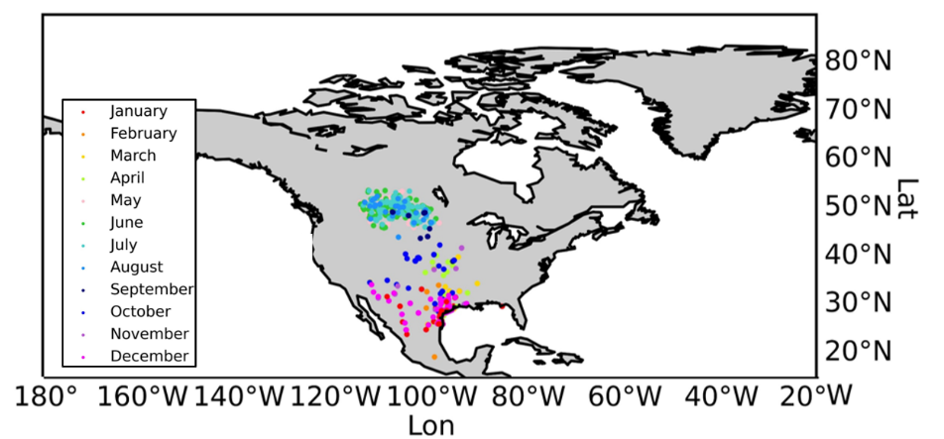

Code:

def map_2(save_path,csv_name):  
 *"""  
 This function is for showing the distribution of raw observation data on the map  
  
 Args:  
 save_path: Path for storing the raw data distribution figures  
 csv_name: Name of the species to be processed  
  
 Returns:  
 True: Omitted  
 """* m = Basemap(llcrnrlat=-60, urcrnrlat=90, llcrnrlon=-180, urcrnrlon=-20) # Instantiate a map  
 m.drawcoastlines() # Draw the coastline  
 m.drawmapboundary(fill_color='white')  
 m.fillcontinents(lake_color='white') # Draw the continents and fill them in white  
  
 parallels = np.arange(-90., 90., 10.) # Draw latitudes with ranges [-90,90] and intervals of 10  
 m.drawparallels(parallels, labels=[False, True, True, False], color='none')  
 meridians = np.arange(-180., 180., 20.) # Draw the longitude with a range of [-180,180] and an interval of 10  
 m.drawmeridians(meridians, labels=[True, False, False, True], color='none')  
  
 # plt.rcParams['figure.figsize'] = (28, 8)  
 # plt.show()  
  
 datalist = readcsv(save_path + csv_name)  
 datalist = datalist[1:]  
  
 LON = []  
 LAT = []  
 for i in range(1):  
 Lat = [[float(data[0]),int(data[2])] for data in datalist]  
 Lon = [[float(data[1]),int(data[2])] for data in datalist]  
 LON.append(Lon)  
 LAT.append(Lat)  
  
 for doc in range(1):  
 colorMap = ['red', 'darkorange', 'gold', 'greenyellow', 'pink', 'limegreen', 'mediumturquoise',  
 'dodgerblue',  
 'navy', 'blue', 'mediumorchid', 'fuchsia']  
 # Show labels  
 label = ['January', 'February', 'March', 'April', 'May', 'June', 'July', 'August', 'September', 'October',  
 'November', 'December']  
  
 marker = ['x', 'o', '.', '+', '<', '_', '^', 'v', 'H', '|', 's', '*']  
 j = 0  
 # print(len(lon))  
 flag = True  
  
 col1 = 43101  
 for i in range(13):  
 # print(i)  
 if doc == 0:  
 # m.plot(LON[doc][i:i + 30], LAT[doc][i:i + 30], marker=marker[doc], linewidth=0.4,  
 # color=colorMap[j],  
 # markersize=0.5, label=label[  
 # j])  
 LON1 = [data[0] for data in LON[doc] if data[1]>=col1 and data[1]<col1 + 30]  
 LAT1 = [data[0] for data in LAT[doc] if data[1]>=col1 and data[1]<col1 + 30]  
 col1 = col1 + 30  
 m.scatter(LON1, LAT1, color=colorMap[j],s=1, label=label[j])  
 # plt.show()  
 j += 1  
 if j == 12:  
 j = 0  
 if flag:  
 plt.legend(loc='lower left', shadow=True)  
 flag = False  
 continue  
  
 plt.xlabel('Lon', labelpad=10)  
 plt.ylabel('Lat')  
 plt.savefig(save_path + '{}.jpg'.format(csv_name.replace('.csv', '')), dpi=1000)  
 # plt.show()  
 plt.close()

1. Get the daily centroids by Mean shift

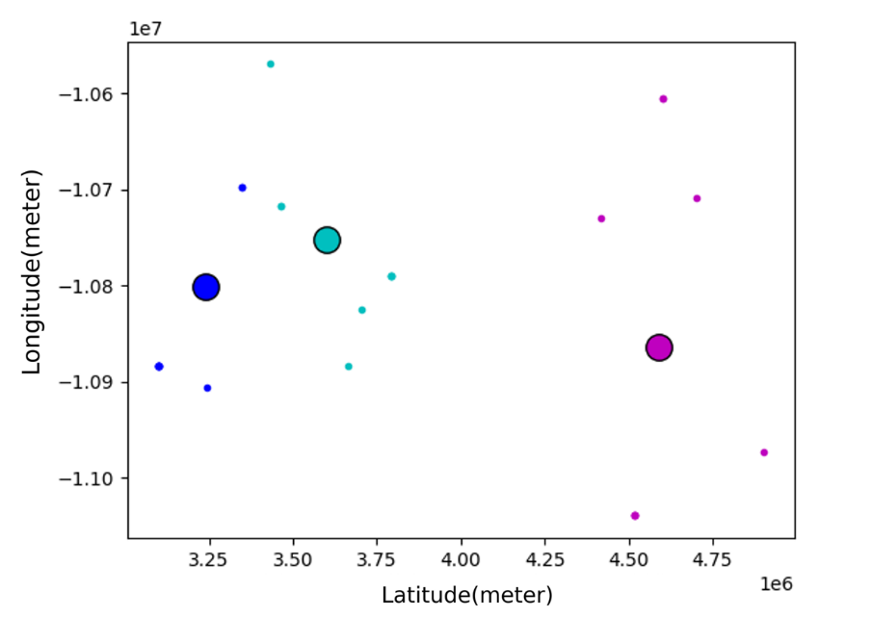

Code:

def mean_shift(SLDF_df,save_path,csv_name):  
 *"""  
 This function is for getting centroids of high-density subgroups by Meanshift algorithm  
  
 Args:  
 SLDF_df: The data after sldf outlier detection  
 save_path: The path for saving the result file  
 csv_name: The species name being processed  
  
 Returns:  
 result: The data results after Meanshift clustering  
 """* # datas = pd.read_excel('data/clean_window_data.xlsx')  
 datas = SLDF_df.drop(['SLDF'], axis=1)  
 result = []  
 result.append(["LATITUDE", "LONGITUDE", "OBSERVATION DATE"])  
 for date in tqdm(range(43101, 43466)):  
 #for date in range(43101, 43119):  
 #print(date)  
 data = datas.loc[date == datas['OBSERVATION DATE']] # .values.tolist()#["answer"]  
 data = data.iloc[:, :2]  
 data = np.array(data)  
 if len(data) == 0:  
 continue  
  
 ms = MeanShift()  
 ms.fit(data)  
 labels = ms.labels_  
 cluster_centers = ms.cluster_centers_  
  
 labels_unique = np.unique(labels)  
 n_clusters = len(labels_unique)  
  
 for c in cluster_centers:  
 result.append([float(c[0]), float(c[1]), date])  
  
 colors = cycle('bcmyk')  
 if date % 10 == 0:  
 for k, color in zip(range(n_clusters), colors):  
 # current_member indicates true if the label is k and false if not  
 current_member = labels == k  
 cluster_center = cluster_centers[k]  
 # Draw plots  
 plt.plot(data[current_member, 0], data[current_member, 1], color + '.')  
 # Draw circles  
 plt.plot(cluster_center[0], cluster_center[1], 'o',  
 markerfacecolor=color,  
 markeredgecolor='k',  
 markersize=14)  
  
 plt.xlabel('Latitude(meter)')  
  
 plt.ylabel('Longitude(meter)')  
 # plt.show()  
 plt.savefig(os.path.join(save_path, csv_name.replace('.csv', ''), 'centroids_{}.jpg'.format(date)), dpi=1000)  
 plt.close()  
 return result

1. Fit the latitude and longitude with date by GAM

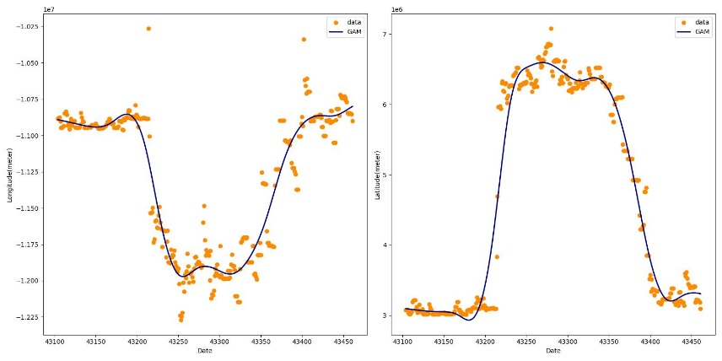

Code:

def gam(save_path, csv_name, key):  
 *"""  
 This function is for gam algorithm  
  
 Args:  
 save_path: The path for saving the result file  
 csv_name: The species name being processed  
 key: The number for file naming  
  
 Returns:  
 Lon: The longitude after GAM fitting  
 Lat: The latitude after GAM fitting  
 """* df = pd.read_csv(os.path.join(save_path, csv_name.replace('.csv', ''), 'group{}.csv'.format(key + 1)))  
 date = df["date_index"]  
 x = df["X"]  
 y = df["Y"]  
 xx = df["date_index"]  
 xx = xx + 43100  
  
  
 gam_model_x = LinearGAM().fit(date, x)  
 gam_model_y = LinearGAM().fit(date, y)  
  
 predictions_x = gam_model_x.predict(date)  
 predictions_y = gam_model_y.predict(date)  
  
 # Draw the pictures  
 plt.figure(figsize=(16, 8))  
 plt.subplot(1, 2, 1)  
 plt.scatter(xx, y, color='darkorange', label='data')  
 plt.plot(xx, predictions_y, color='navy', lw=2, label='GAM')  
 # plt.plot(X_all, y_gb_longitude_pred, color='c', lw=2, label='Gradient Boosting')  
 plt.xlabel('Date')  
 plt.ylabel('Longitude(meter)')  
 #plt.title('Longitude')  
 plt.legend()  
  
 plt.subplot(1, 2, 2)  
 plt.scatter(xx, x, color='darkorange', label='data')  
 plt.plot(xx, predictions_x, color='navy', lw=2, label='GAM')  
 # plt.plot(X_all, y_gb_latitude_pred, color='c', lw=2, label='Gradient Boosting')  
 plt.xlabel('Date')  
 plt.ylabel('Latitude(meter)')  
 #plt.title('Latitude')  
 plt.legend()  
 plt.tight_layout()  
 # plt.show()  
 plt.savefig(os.path.join(save_path, csv_name.replace('.csv', ''), 'gam{}.jpg'.format(key + 1)))  
 plt.close()

1. Fit the latitude and longitude with date by Random Forests

Code:

def randomforest(save_path, csv_name,key,n_estimators,random_state):  
 *"""  
 This function is for Random forests algorithm  
  
 Args:  
 save_path: The path for saving the result file  
 csv_name: The species name being processed  
 key: The number for file naming  
 n_estimators: The number of trees  
 random_state: randomness  
  
 Returns:  
 Lon: The longitude after Random Forests algorithm  
 Lat: The latitude after Random Forests algorithm  
  
 """* df = pd.read_csv(os.path.join(save_path, csv_name.replace('.csv', ''), 'group{}.csv'.format(key + 1)))  
 date = df["date_index"]  
 xx = df["date_index"]  
 xx = xx + 43103  
  
 X = df[['date_index']] # Features (date)  
 y_longitude = df['Y'] # Target variable (longitude)  
 y_latitude = df['X'] # Target variable (latitude)  
  
 # Train the model  
 rf_longitude = RandomForestRegressor(n_estimators=n_estimators,random_state=random_state)  
 rf_latitude = RandomForestRegressor(n_estimators=n_estimators,random_state=random_state)  
 rf_longitude.fit(X, y_longitude)  
 rf_latitude.fit(X, y_latitude)  
  
 y_rf_longitude_pred = rf_longitude.predict(X)  
 y_rf_latitude_pred = rf_latitude.predict(X)  
  
  
 # Draw the pictures  
 plt.figure(figsize=(16, 8))  
 plt.subplot(1, 2, 1)  
 plt.scatter(xx, y_longitude, color='darkorange', label='data')  
 plt.plot(xx, y_rf_longitude_pred, color='navy', lw=2, label='Random Forest')  
 # plt.plot(X_all, y_gb_longitude_pred, color='c', lw=2, label='Gradient Boosting')  
 plt.xlabel('Date')  
 plt.ylabel('Longitude(meter)')  
 #plt.title('Longitude')  
 plt.legend()  
  
 plt.subplot(1, 2, 2)  
 plt.scatter(xx, y_latitude, color='darkorange', label='data')  
 plt.plot(xx, y_rf_latitude_pred, color='navy', lw=2, label='Random Forest')  
 # plt.plot(X_all, y_gb_latitude_pred, color='c', lw=2, label='Gradient Boosting')  
 plt.xlabel('Date')  
 plt.ylabel('Latitude(meter)')  
 #plt.title('Latitude')  
 plt.legend()  
 plt.tight_layout()  
 # plt.show()  
 plt.savefig(os.path.join(save_path, csv_name.replace('.csv', ''), 'randomforest{}.jpg'.format(key + 1)))  
 plt.close()

1. Fit the latitude and longitude with date by K-Nearest Neighbors

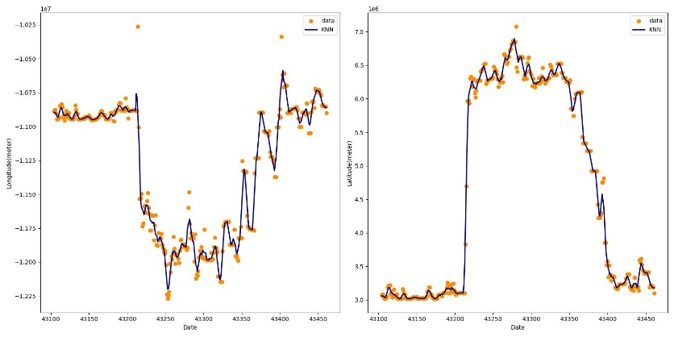

Code:

def knn(save_path, csv_name,key,n_neighbors):  
 *"""  
 This function is for KNN algorithm  
  
 Args:  
 save_path: The path for saving the result file  
 csv_name: The species name being processed  
 key: The number for file naming  
 n_neighbors: The number of neighbors  
  
 Returns:  
 Lon: The longitude after KNN fitting  
 Lat: The latitude after KNN fitting  
  
 """* df = pd.read_csv(os.path.join(save_path, csv_name.replace('.csv', ''), 'group{}.csv'.format(key + 1)))  
 date = df["date_index"]  
 xx = df["date_index"]  
 xx = xx + 43103  
  
 X = df[['date_index']] # Features (date)  
 y_longitude = df['Y'] # Target variable (longitude)  
 y_latitude = df['X'] # Target variable (latitude)  
  
  
 # Train the model  
 knn_longitude = KNeighborsRegressor(n_neighbors=n_neighbors)  
 knn_latitude = KNeighborsRegressor(n_neighbors=n_neighbors)  
 knn_longitude.fit(X, y_longitude)  
 knn_latitude.fit(X, y_latitude)  
  
 y_knn_longitude_pred = knn_longitude.predict(X)  
 y_knn_latitude_pred = knn_latitude.predict(X)  
  
 # Draw the pictures  
 plt.figure(figsize=(16, 8))  
 plt.subplot(1, 2, 1)  
 plt.scatter(xx, y_longitude, color='darkorange', label='data')  
 plt.plot(xx, y_knn_longitude_pred, color='navy', lw=2, label='KNN')  
 # plt.plot(X_all, y_gb_longitude_pred, color='c', lw=2, label='Gradient Boosting')  
 plt.xlabel('Date')  
 plt.ylabel('Longitude(meter)')  
 #plt.title('Longitude')  
 plt.legend()  
  
 plt.subplot(1, 2, 2)  
 plt.scatter(xx, y_latitude, color='darkorange', label='data')  
 plt.plot(xx, y_knn_latitude_pred, color='navy', lw=2, label='KNN')  
 # plt.plot(X_all, y_gb_latitude_pred, color='c', lw=2, label='Gradient Boosting')  
 plt.xlabel('Date')  
 plt.ylabel('Latitude(meter)')  
 #plt.title('Latitude')  
 plt.legend()  
 plt.tight_layout()  
 # plt.show()  
 plt.savefig(os.path.join(save_path, csv_name.replace('.csv', ''), 'KNN{}.jpg'.format(key + 1)))  
 plt.close()

1. Show the trajectories according to different centroids fitting model

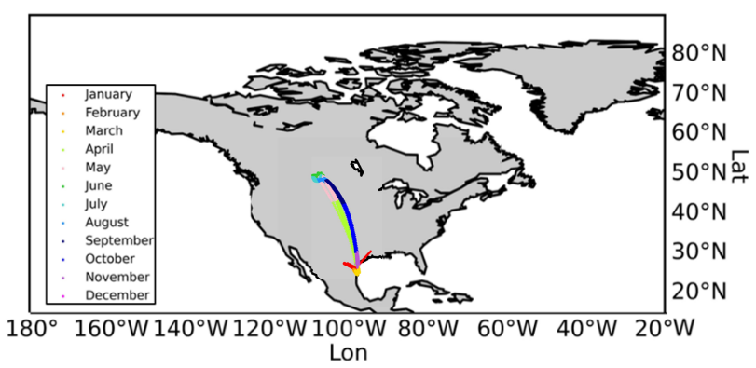

1. Results of trajectory estimation with GAM fitting

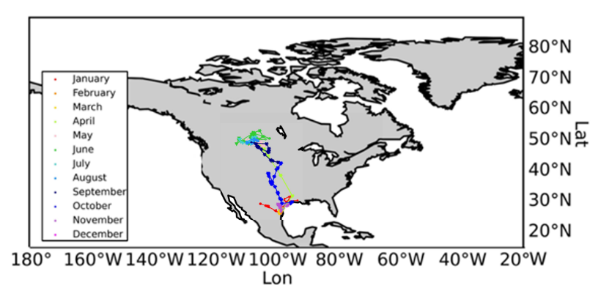

1. 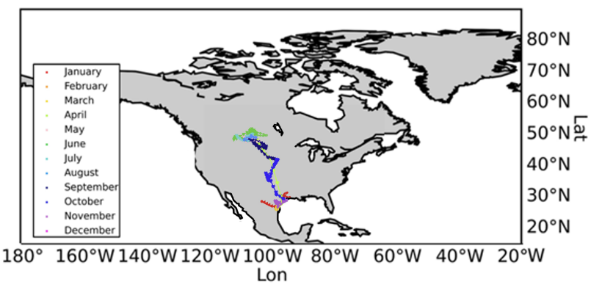Results of trajectory estimation with RF fitting
2. Results of trajectory estimation with K-NN fitting

Code:

def map_1(save_path,csv_name,type_name, ):  
 *"""  
 This function is for showing the trajectories on the map  
  
 Args:  
 save_path: The path for storing the result figures  
 csv_name: The name of the species to be processed  
 type_name: The fitting model chosen for centroids fitting  
  
 Returns:  
 True: Omitted  
  
 """* # plt.rcParams['figure.figsize'] = (28, 8)  
 # plt.show()  
  
 excel_list = os.listdir(os.path.join(save_path, csv_name.replace('.csv', '')))  
 excel_list1 = []  
 for csv_excel in excel_list:  
 if 'group' in csv_excel:  
 excel_list1.append(csv_excel)  
  
 LON = []  
 LAT = []  
 for i in range(len(excel_list1)):  
 if type_name == 'gam':  
 Lon, Lat = gam(save_path, csv_name, i)  
 elif type_name == 'randomforest':  
 n_estimators = 100  
 random_state = 42  
 Lon, Lat = randomforest(save_path, csv_name, i,n_estimators,random_state)  
 elif type_name == 'knn':  
 n_neighbors = 5  
 Lon, Lat = knn(save_path, csv_name, i,n_neighbors)  
  
 LON.append(Lon)  
 LAT.append(Lat)  
  
 m = Basemap(llcrnrlat=-60, urcrnrlat=90, llcrnrlon=-180, urcrnrlon=-20) # Instantiate a map  
 m.drawcoastlines() # Draw the coastline  
 m.drawmapboundary(fill_color='white')  
 m.fillcontinents(lake_color='white') # Draw the continents and fill them in white  
  
 parallels = np.arange(-90., 90., 10.) # Draw latitudes with ranges [-90,90] and intervals of 10  
 m.drawparallels(parallels, labels=[False, True, True, False], color='none')  
 meridians = np.arange(-180., 180., 20.) # Draw the longitude with a range of [-180,180] and an interval of 10  
 m.drawmeridians(meridians, labels=[True, False, False, True], color='none')  
 for doc in range(0, len(LON)):  
 colorMap = ['red', 'darkorange', 'gold', 'greenyellow', 'pink', 'limegreen', 'mediumturquoise',  
 'dodgerblue',  
 'navy', 'blue', 'mediumorchid', 'fuchsia']  
 # Show labels  
 label = ['January', 'February', 'March', 'April', 'May', 'June', 'July', 'August', 'September', 'October',  
 'November', 'December']  
  
 marker = ['x', '.', 'o', '|', '*', '.', '<', '>', ',', '.', '.', 'v', 'x', 'o', '|', '*', '<', '^', '.', '*', 'v', '*', ',', 'y', '.', '.', '.', '.']  
 j = 0  
 # print(len(lon))  
 flag = True  
  
  
 for i in range(0, len(LON[doc]) - 30, 30):  
 # print(i)  
 if doc == 0:  
 m.plot(LON[doc][i:i + 30], LAT[doc][i:i + 30], marker=marker[doc], linewidth=0.4,  
 color=colorMap[j],  
 markersize=0.5, label=label[  
 j])  
 # plt.show()  
 j += 1  
 if j == 12:  
 j = 0  
 if flag:  
 plt.legend(loc='lower left', shadow=True)  
 flag = False  
 continue  
 else:  
 m.plot(LON[doc][i:i + 30], LAT[doc][i:i + 30], marker=marker[doc], linewidth=0.4,  
 color=colorMap[j],  
 markersize=0.5)  
 # plt.show()  
 j += 1  
 if j == 12:  
 j = 0  
 if flag:  
 plt.legend(loc='lower left', shadow=True)  
 flag = False  
 continue  
  
 plt.xlabel('Lon', labelpad=10)  
 plt.ylabel('Lat')  
 plt.savefig(os.path.join(save_path, csv_name.replace('.csv', ''), 'trajectories.jpg'), dpi=1000)  
 # plt.show()  
 plt.close()

1. 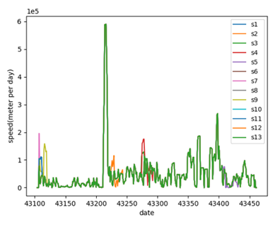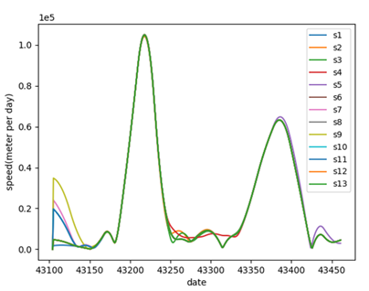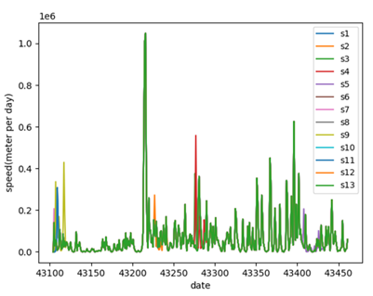Speed calculation according to different centroids fitting model

Code:

def calculate_speed(path):  
 *"""  
 This function is for calculating the speed  
  
 Args:  
 path: The file path  
  
 Returns:  
 list_speed: The speed results  
   
 """* df = pd.read_csv(path, header=None)  
 list_speed = [0]  
 for i in range(1,358):  
 # x1 = float(df.iloc[i + 1, 0])  
 x = float(df.iloc[i + 1, 0]) - float(df.iloc[i, 0])  
 y = float(df.iloc[i + 1, 1]) - float(df.iloc[i, 1])  
 distance = (x ** 2 + y ** 2) ** 0.5  
 list_speed.append(distance)  
 return list_speed  
  
def speed_main(path):  
 *"""  
 This function is for saving and drawing the results  
  
 Args:  
 path: The file path  
  
 Returns:  
 True: Omitted  
   
 """* path1 = get_file_list(path)  
 list_averange = []  
 index = 1  
 xx = [i for i in range(43104,43462)]  
 for i in path1:  
 name1 = os.path.basename(i)  
 if name1[0:2] == 'fi':  
 #print(name1)  
 result = calculate_speed(i)  
 result1 = [[datas] for datas in result]  
 # result2 = []  
 # for k in range(len(result)):  
 # result2.append([43101 + k,result[k]])  
 savecsvs(os.path.join(path, 'speed', 's{}.csv'.format(str(index))),result1)  
 list_averange.append(result)  
  
 #plt.xlim(0,600)  
 plt.plot(xx,result,label='s{}'.format(str(index)))  
 #plt.plot(xx, result)  
 plt.xlabel("date")  
 plt.ylabel("speed(meter per day)")  
 #plt.title('%s'%i)  
 index = index + 1  
  
 result2 = []  
 for m in range(len(list_averange[0])):  
 sum = 0  
 for n in range(len(list_averange)):  
 sum = sum + float(list_averange[n][m])  
 #savecsv(os.path.join(path, 'speed', 'sa.csv'),[sum/len(list_averange)])  
 result2.append(sum/len(list_averange))  
  
  
 plt.ticklabel_format(style='scientific', axis='y', scilimits=(0, 0))  
 plt.legend()  
 plt.savefig(os.path.join(path, 'speed', 'SpeedPerDay.png'))  
 plt.show()

1. Offset distance calculation according to different centroids fitting model

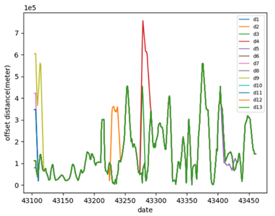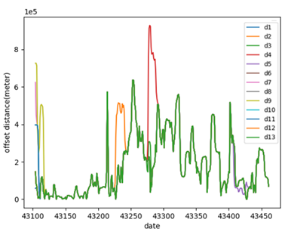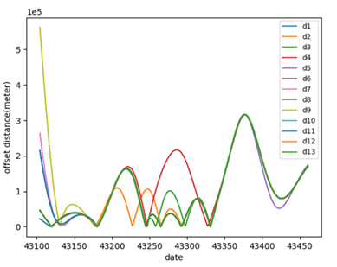

Code:

def get_distance_point2line(point, line):  
 *"""  
 This function is for calculating the distance from points to a line  
  
 Args:  
 point: The observation points  
 line: A line  
  
 Returns:  
 distance: The distance from points to the line  
   
 """* line_point1, line_point2 = np.array(line[0:2]), np.array(line[2:])  
 vec1 = line_point1 - point  
 vec2 = line_point2 - point  
 distance = np.abs(np.cross(vec1, vec2)) / np.linalg.norm(line_point1 - line_point2)  
 return distance  
  
#Index calculation of offset distance  
def calculate_distance(path_list):  
 *"""  
 This function is for getting migration axis and offset distance  
  
 Args:  
 path_list: The files in the path  
  
 Returns:  
 list11: The offset distances  
   
 """* list_distance = []  
 for l in path_list:  
 name1 = os.path.basename(l)  
 if name1[:2] == 'fi':  
 tmp = pd.read_csv(l, header=None)  
 list_distance.append(tmp)  
  
 mean_x = []  
 mean_y = []  
 for q in list_distance:  
 mean_x.append(float(q.iloc[1, 0]))  
 mean_y.append(float(q.iloc[1, 1]))  
  
 mean_x1 = np.mean(mean_x)  
 mean_y1 = np.mean(mean_y)  
 print(mean_x1, mean_y1)  
  
  
 dict1 = {}  
 list1 = []  
 max_list_x = []  
 max_list_y = []  
 for r in path_list:  
 name1 = os.path.basename(r)  
 if name1[0:2] == 'fi':  
 tmp = pd.read_csv(r, header=None)  
 for l in range(1,359):  
 x1 = float(tmp.iloc[1, 0])  
 y1 = float(tmp.iloc[1, 1])  
  
 x = float(tmp.iloc[l, 0])  
 y = float(tmp.iloc[l, 1])  
 distance1 = ((x - x1) ** 2 + (y - y1) ** 2) ** 0.5  
 dict1[distance1] = l  
 list1.append(distance1)  
 max_distance = max(list1)  
 max_x_1 = float(tmp.iloc[dict1[max_distance], 0])  
 max_y_1 = float(tmp.iloc[dict1[max_distance], 1])  
 max_list_x.append(max_x_1)  
 max_list_y.append(max_y_1)  
 list1 = []  
 dict1 = {}  
  
 mean_x2 = np.mean(max_list_x)  
 mean_y2 = np.mean(max_list_y)  
 print(mean_x2, mean_y2)  
  
  
 line = [mean_x1, mean_y1, mean_x2, mean_y2]  
  
 list11 = []  
 for r in path_list:  
 list_tmp = []  
 name1 = os.path.basename(r)  
 if name1[0:2] == 'fi':  
 tmp = pd.read_csv(r, header=None)  
 for p in range(1,359):  
 x = float(tmp.iloc[p, 0])  
 y = float(tmp.iloc[p, 1])  
 distance2 = get_distance_point2line((x, y), line)  
 list_tmp.append(distance2)  
 list11.append(list_tmp)  
 return list11  
  
def off_distance_main(path):  
 *"""  
 This function is for saving and drawing the results  
  
 Args:  
 path: The file path  
  
 Returns:  
 True: Omitted  
   
 """* path1 = get_file_list(path)  
 result = calculate_distance(path1)  
 count1 = 0  
 tmp = 0  
 index = 1  
 for j in result:  
 list_averange = []  
 result2 = []  
 items = [[datas] for datas in j]  
 savecsvs(os.path.join(path, 'off_distance', 'd{}.csv'.format(str(index))),items)  
 index = index + 1  
 for b in range(len(j)):  
 for l in result:  
 tmp += l[b]  
 averange = int(tmp/len(result))  
 tmp = 0  
 result2.append(averange)  
 items = [[datas] for datas in result2]  
 #savecsvs(os.path.join(path, 'off_distance', 'da.csv'), items)  
  
 count = 1  
 xx = [i for i in range(43104, 43462)]  
 for l in result:  
 name = os.path.basename(path1[count])  
 #plt.xlim(0,360)  
 plt.plot(xx,l,label='d{}'.format(count))  
 #plt.plot(xx, l)  
 plt.xlabel("date")  
 plt.ylabel("offset distance(meter)")  
 #plt.title('%s'%l)  
 count += 1  
 #plt.title('%s'%name)  
  
 plt.ticklabel_format(style='scientific', axis='y', scilimits=(0, 0))  
 plt.legend()  
 plt.savefig(os.path.join(path, 'off_distance', 'OffsetDistancePerDay.png'))  
 plt.show()

1. Centroid average distances

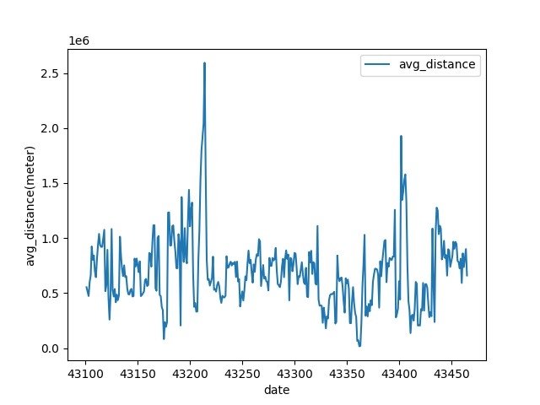

Code:

def get_avg(datalist):  
 *"""  
 This function is for obtaining the average distance  
  
 Args:  
 datalist: The data to be processed  
  
 Returns:  
 avg: The average distance  
   
 """* data1 = [datalist[0][0],datalist[0][1]]  
 avg_datalist = []  
 for i in range(1,len(datalist)):  
 datas = [datalist[i][0],datalist[i][1]]  
 avg_datalist.append(dist_eclud(data1,datas))  
 if avg_datalist:  
 avg = sum(avg_datalist)/(len(datalist) - 1)  
 else:  
 avg = 0  
 return avg  
   
#Calculate the average Euclidean distance for daily centroids  
def avg_distance(save_path):  
 *"""  
 This function is for calculating the average distance for daily centroids  
  
 Args:  
 save_path: The path of files  
  
 Returns:  
 True: Omitted  
   
 """* df=pd.read_csv(os.path.join(save_path, 'centroids.csv'))  
 train_data = np.array(df)  
 excel_list = train_data.tolist() # list  
 # excel_list = excel_list[1:]  
  
 datelist = get_date_list(excel_list)  
  
 avg_list = []  
 for date in datelist:  
 same_date = get_same_date_list(date,excel_list)  
 avg_date = get_avg(same_date)  
 avg_list.append(avg_date)  
 savecsv(os.path.join(save_path, 'avg.csv'),[date,avg_date])  
  
 plt.plot(datelist, avg_list, label="avg_distance")  
 plt.xlabel("date")  
 plt.ylabel("avg_distance(meter)")  
 plt.legend(loc="best")  
 plt.gca().ticklabel_format(axis="x", useOffset=False)  
 plt.savefig(os.path.join(save_path, 'avg.png'))  
 plt.show()